**BYLAWS**

**Bylaws of Coles Parent Teacher Organization**

**Article I — Name**

The name of this organization is the Coles Elementary Parent Teacher Organization (PTO). Hereafter, the organization will be referred to as the “Coles PTO.”

# Article II — Goals

The goals of the Coles PTO are:

1. To foster the relationship between the school, parents, students, and teachers to create a positive learning environment for the school community.
2. To support the education of all children physically, mentally, and socially**.**

The purpose of the Coles PTO is governed by the policies set forth in Article III.

**Article III—Basic Policies**

1. The Coles PTO is organized exclusively for educational, literary, charitable, or scientific purposes within the meaning of Section 501(c)(3) of the IRS Code- nonprofit tax exempt. Upon dissolution of the organization, assets shall be distributed for one or more exempt purposes within the meaning of Section 501(c)(3) of the Internal Revenue Code, or corresponding section of any future federal tax code, or shall be distributed to the federal government, or to a state or local government, for a public purpose. Any such assets not disposed of shall be disposed of by a court of competent jurisdiction in the county in which the principal office of the organization is then located, exclusively for such purposes or to such organization or organizations, as said Court shall determine, which are organized and operated exclusively for such purposes.
2. The Coles PTO shall be non-commercial, nonpartisan and will not discriminate in regards to race, color, sex, sexual orientation, or national origin.
3. The Coles PTO or any members in their official capacities shall not participate or intervene in any political campaign on behalf of, or in opposition to, any candidate for public office.
4. The Coles PTO’s net earnings shall not be used for the benefit of, or be distributed to its members or other private entities, with the exception that the Coles PTO shall be authorized to reimburse members for personal money spent on purposes pre-approved by the Coles PTO Board. To be reimbursed an individual must first have prior approval from the Executive Board for the specific purchase and then must submit a copy of the receipt along with a reimbursement request form to the Treasurer.
5. Copies of minutes, agendas and treasurer records shall be made available to be reviewed by all members in good standing at all times.

**Article IV — Membership and Dues**

1. Membership in the Coles PTO is available to the parent(s), grandparent(s), legal guardian(s) of any children attending Coles Elementary School and Coles staff members.
2. The Coles PTO Board will establish the cost of annual dues by July 1st of the upcoming school year.
3. The Coles PTO will conduct an annual enrollment of members, but will admit eligible persons to membership at any time upon receipt of membership application and dues, if applicable. Dues for PTO membership will not be prorated.
4. All memberships received during the school year will expire on June 30th of each year.
5. Coles PTO members are eligible to participate in the PTO meetings, to vote on matters before the PTO Board, and to serve in its elected or appointed positions.

**Article V — Election of the PTO Board**

Section 1. Board Nomination

1. All PTO members are eligible to be nominated to hold a position on the Board, except that the Treasurer shall not be a staff member of Coles Elementary.
2. Only those persons who agree to have their names put forth as a nominee will be considered.
3. The Board will publicize the election meeting date and hold an election during the May meeting of each school year. Nomination forms will be made available during the April meeting. If the meeting during May cannot be held as scheduled due to unavoidable circumstances, the executive board and school principal will work together to reschedule it.
4. The vote shall be conducted by written ballot or electronically and a simple majority vote shall elect. Should there be a tie, the top two candidates for that office shall be subject to a second ballot vote at the June PTO meeting. Should there be another tie, the sitting PTO President shall cast the deciding vote provided he/she is not a candidate for that particular office. If the PTO president is a candidate, the Vice President shall cast the deciding vote. If the PTO Vice President is a candidate, the Secretary shall cast the deciding vote. (This process shall continue in succession until a qualified Executive Board Member votes.)
5. Absentee Voting. The PTO does not allow absentee voting during the annual election.
6. Terms of Office. Officers shall assume their official duties no later than July 1st in the year in which they are elected and shall serve for a term of one year or until their successors are elected.

1. Vacancies. If there is a vacancy in the office of president, the vice president will become the president. At the next regularly scheduled meeting, a new vice president will be elected by written or electronic ballot after nominations from the floor. If there is a vacancy in any other office, members will fill the vacancy through an election at the next regular meeting.
2. Removal from Office. Officers can be removed from office with or without cause by a two-thirds vote of those present (assuming a quorum) at a regular meeting where previous notice has been given.
3. The Board will then publicize the names of those elected to the PTO membership and to the school at large.

Section 2. PTO Elected Board

The elected officers of the Coles PTO will include the President, Vice-President, Secretary, and Treasurer.

1. Officers will assume their official duties July 1st of the upcoming school year for which they were elected.
2. Officers shall attend each Coles PTO meeting unless notice is given to the PTO Board prior to the meeting.
3. Officers will serve in their capacity for the current school year for which they were elected. Each person elected shall hold only one office at a time.
4. Members of the PTO Board will have the option to run for the next school year, not to exceed three full elected one-year terms in any one position.
5. Resignation from the Elected Board will cause the PTO Board to vote on a replacement for the remainder of the term.

# Article VI — Duties of Officers

Section 1. The President

The President shall preside at all meetings of the PTO and of the PTO Board; shall perform such duties as prescribed in these bylaws or assigned to him/her by the PTO Board; and shall coordinate the work of the Coles PTO and its committees in order that the goals of the PTO may be promoted.

Other duties include:

* Prepare meeting agendas for monthly meetings, share with secretary for distribution
* Sit with principal and set meeting dates, fundraiser and family fun night dates and times. Will also set PTO newsletter dates for the year, along with secretary.
* Prepare school-wide letter, due in June for August’s Registration packet
* In June, assist Treasurer to establish the preliminary budget for following school year.
* Check PTO mail in the office and distribute appropriately
* Provide all official signing/authorization for contracts, application, etc.
* Maintain open and frequent communication with school Principal, keeping Principal informed of all PTO activities/ideas
* Be a co-signer on the Coles PTO bank account to assist the treasurer when needed.
* Oversee all areas of the PTO
* Appoint individuals to serve as committee chairs.

Section 2. The Vice President

The Vice President shall:

* Act as an aide to the President, perform the duties of the President in the absence or disability of the President, and will assume the duties of President if the President cannot fulfill the term of office.
* Attend monthly PTO meetings
* Oversee all PTO committees and events for the school year and may assign alternate Executive Board member to serve on a committee and/or event.
* Provide leadership on the planning efforts for events and ensure all event related communication (flyers, emails, social media) are distributed once approved by PTO President.
* Chair or designate a chair for each event for the school year.
* Ensure all activities meet the goals set forth and remain within budget.
* Coordinate with Treasurer for all event related purchases. Request a formal budget amendment should the need arise.
* Be a co-signer on the bank account to assist the treasurer when needed.

Section 3. The Secretary

The Secretary will:

* Attend monthly PTO meetings
* Record the minutes of all proceedings
* Maintain a list of members, updating as new members are enrolled. Provide copies to the Treasurer for recordkeeping purposes.
* Provide approved minutes on PTO website
* Manage the correspondence of the organization and/or reads correspondence at executive board and PTO meetings as requested by the president
* Maintain e-mail database of all PTO members
* Maintain and update all social media and website activity on behalf of the PTO
* Work with school principal and PTO president to inform school community about PTO activities

Section 4. The Treasurer

The Treasurer shall:

* Attend monthly PTO meetings
* Have custody of the funds of the Coles PTO. All funds collected must be deposited into the designated bank account within 72 business hours of collection.
* Keep a full and accurate account of receipts and expenditures, and make disbursements in accordance with the adopted budget.
* Present a financial statement at each meeting of the Coles PTO.
* Prepare an annual IRS tax return, an end-of-year financial statement, and arrange for an annual audit to be conducted.
* Work with the Secretary on the maintenance of membership records.
* Submit all requested/required financial data relating to PTO operations to the Finance Audit Committee Chair within two weeks prior to the close of the fiscal year, for the purposes of the Treasurer's accounts being audited by the Finance Audit Committee.

**Article VII — Roles and Responsibilities of the Committee Chairs**

Committee Chairs are appointed by the PTO President and are an invaluable part of the team. All chairs will work with the Executive Board to promote the PTO goals.

Sections 1. Staff Appreciation Committee Chair shall:

* Oversee and coordinate the activities for staff appreciation.
* Planning of luncheons, events and appreciation should be planned at the beginning of the school year and be approved by the PTO executive board.
* Committee chair can ask the Volunteer chair for support to utilize an online sign up for support and needed volunteers.
* Work with Treasurer for any financial, budgeting and purchasing needs.
* Prepare a brief monthly report to be presented at the PTO Meeting
* Maintain a job file to be given to successor.

Sections 2. Spirit Wear Committee Chair shall:

* Oversee and coordinate the spirit wear options with approval from the PTO executive board.
* Work with treasurer with regards to budgeting, costs and incoming monies.
* Create informative fliers or order forms for distribution and sharing. These must be have approval from the PTO president prior to copying and distribution.
* Prepare a brief monthly report to be presented at the PTO General Meeting
* Maintain a job file to be given to successor.

Section 3. Spirit Night Committee Chair shall:

* Oversee and coordinate spirit nights for the year in coordination with PTO executive board.
* Create and print flyers for each event approximately 4 weeks before scheduled date. All fliers must be pre-approved by the PTO president prior to printing. Once printed, the flyers should be given to the front office staff for distribution.
* Share the fliers or handouts with the corresponding secretary for web and social media postings.
* Prepare a brief monthly report to be presented at the PTO Meeting
* Maintain a job file to be given to successor.

Section 4. Box Top for Education Committee Chair shall:

* Organize and oversee the collection, organization and turn in of box tops for the November 1st and March 1st yearly deadlines.
* Promotions and class/grade incentives can be created with the PTO executive board approval.
* Responsible for printing and giving collection forms to the front office secretaries for distribution after PTO president approval.
* Prepare a brief monthly report to be presented at the PTO General Meeting
* Maintain a job file to be given to successor.

Section 5. Community Partnerships Committee Chair shall:

* Oversee and coordinate community opportunities for financial support for Coles PTO. (Examples of organizations are Target, Amazon…etc)
* Create informational flyers for distribution to explain opportunities to support our school. Grocery chair can print and give flyers to front office secretaries for distribution after approval from PTO president. Should share with corresponding secretary for web and social media distribution.
* Prepare a brief monthly report to be presented at the PTO General Meeting
* Maintain a job file to be given to successor.

Section 6. Finance Audit Chairperson

The Finance Audit Committee shall be made up of up to three PTO members that do not currently serve on the Executive Board. The Finance Audit Chair shall audit the financial records of the PTO and prepare a fiscal year-end audit report.

**Article VIII — Structure of the Coles PTO**

Section 1. PTO Board

The Coles PTO Board will consist of the PTO Elected Board, the school Principal, Vice Principal.

Section 2. Duties

The duty of the Coles PTO will be to transact business necessary to achieve its goals. Committee chairs will report the progress of their committee, during the PTO meetings, or as requested by the PTO Board.

The Coles PTO does not have the authority to direct the administrative activities of the school or its policies.

The Coles PTO is authorized to make suggestions and recommendations to the administration regarding activities that would benefit Coles Elementary as it relates to the Coles PTO goals.

Section 3. Meetings

Meetings of the Coles PTO Board will be held at least five times a year, but preferably monthly during the school year. Special meetings of the Coles PTO Board may be called by the President or by the Principal.

A minimum of 50% of the Coles PTO Board shall constitute a quorum for the transaction of business at any PTO meeting.

The primary method of voting at meetings shall be by voice vote, unless a different form (e.g., ballot, electronic) is approved by a majority of the Coles PTO Board and in the case of elections.

Regular meetings of the Coles PTO membership will be held during the school year. These meetings will be the third Wednesday of each month at 6:00pm at Coles Elementary.

Section 4 Signature Authority

Those persons authorized to sign checks and drafts drawn on the accounts of the Coles PTO will be the Treasurer, the President and the Vice President.

Section 6. Budget

The PTO Board shall prepare an annual working budget of the Coles PTO funds for review and approval by the membership at the September meeting. The fiscal year of the PTO will begin on July 1 and end on June 30 of the following calendar year.

The annual budget can be amended if a need should arise. In order to amend the budget, the proposal must be brought to the PTO President to be added to the agenda to be voted on at the next general PTO meeting.

Section 7. Removal

Elected officers can be removed from office with or without cause by a 2/3 vote of the PTO Board.

**Article IX— Parliamentary Procedure**

Robert’s Rules of Order Revised will govern the Coles PTO in all cases in which they are applicable. (Attachment: Robert’s Rules of Order Revised)

**Article X — Bylaw Amendment**

The Coles PTO bylaws may be amended when deemed appropriate. The amended or new bylaw shall be presented at a regularly scheduled meeting of the Coles PTO. The PTO membership must approve the new bylaw or amendment by two-thirds vote of those voting. Public notice of the proposed amendment must be distributed to members at least 15 days prior to the meeting.

Signed: Date: __________________

President

Signed: Date:___________________

Secretary

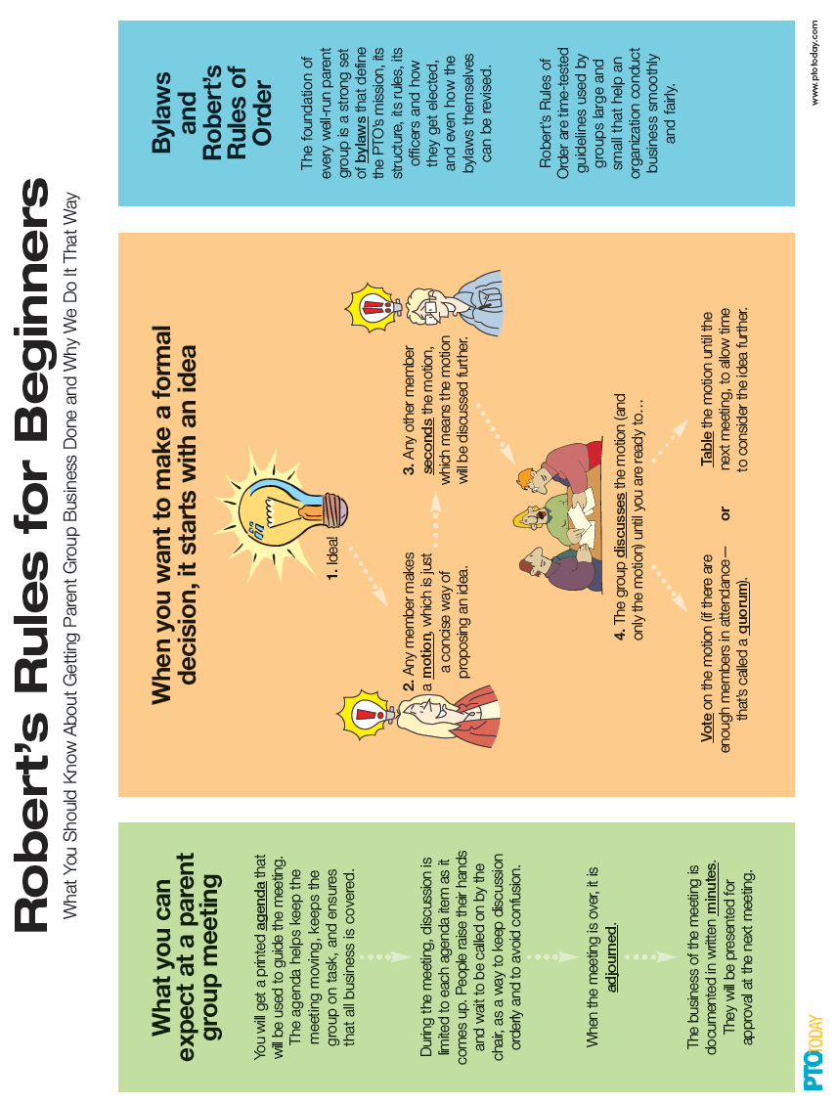



**PTO Board Election Checklist for Nominating Chair**

* Voting is limited to dues-paying PTO members.
* There can be multiple nominations for each position. The only restriction is that you need to be a PTO Member to be nominated.
* Nominations should be confirmed with the nominees prior to a name being added to the ballot.
* At the Election Meeting, additional nominations can be made from the floor.
* Each nominee shall say a few words during the elections.
* Before the election, appoint a committee of two or three people to count the ballots.

* Choose people who are not current officers and are not running for office.
* Have them retire to a corner of the room to count the ballots without interruption, and make sure they double-check the count.
* Announce the results immediately once the committee is finished counting.